RESEARCH PROPOSAL FORM
(also referred to as the ‘Statement of Intent Form’, or SOI)

To be submitted by the researcher to the Institute Research Sub-Committee (IRC)

Research Title:
Evaluating Multimodal Accessibility and Cognitive Load using AI: A Predictive and Educational Tool for Web Designers and Developers
Institute name
IICT
Course / Programme:
Creative Computing
Level and year of study
Level 6, year 3
Main area of study being proposed:
This research explores digital accessibility through a multimodal lens, emphasizing the importance of inclusive web design practices that accommodate individuals with diverse impairments, including visual, auditory, motor, and cognitive. Within this broader field, the study focuses on the European Accessibility Act (EAA) as the central framework for ensuring accessibility across digital environments, examining how artificial intelligence (AI) can evaluate and predict the cognitive strain caused by various website design choices. It investigates the potential for AI-driven tools to deliver personalized accessibility feedback across multiple modalities, guided by the EAA’s legal requirements and indirectly informed by the technical principles of the Web Content Accessibility Guidelines (WCAG), on which the Act is based. By doing so, the research aims to guide developers toward creating digital experiences that are inherently accessible through visual, auditory, and interactive channels.

Name of Researcher:  Mireya Francesca Vella | Researcher’s I.D. Number:  0307604L
Signature of Researcher  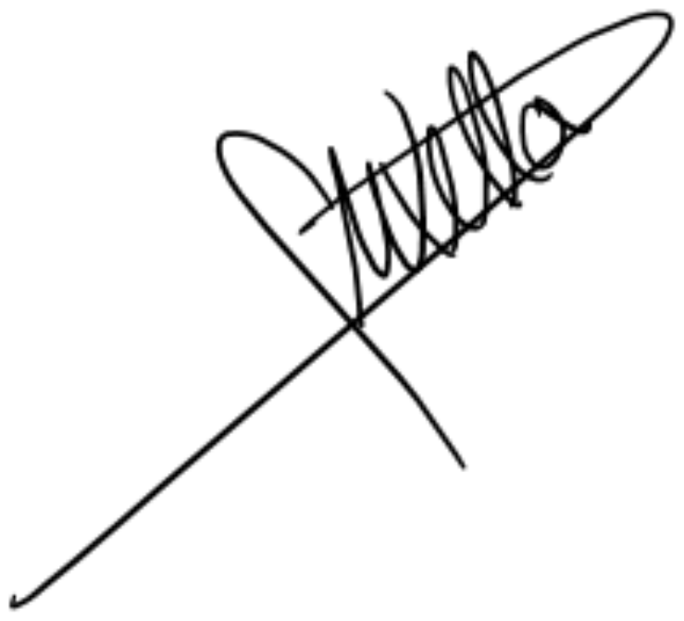 | Date of submission of Form  13/11/2025
Name of Tutor (or Recommended Tutor):
Paul Pulis

Personal Motivation for the Choice of Research Theme.
Enter details here:

The motivation behind this research stems from witnessing first-hand the challenges businesses encounter regarding digital accessibility compliance. A case involving legal action against a company due to non-compliance with web accessibility standards illustrates the serious implications of inaccessible digital design. While current accessibility evaluation tools are effective in identifying technical compliance issues, they often fail to account for the cognitive challenges experienced by users with diverse multimodal accessibility needs. This research aims to develop an AI-driven solution that not only ensures adherence to legal standards but also proactively assesses cognitive load, thereby promoting more inclusive and user-centred web experiences.

Outline of Key Literature and Theoretical Framework or Propositions.
Enter details here:
Cognitive load and multimodal accessibility have become core themes in accessibility engineering, as scholars recognise that compliance alone cannot ensure equitable or low-strain user experiences. The literature from [1]-[17] reflects a decisive turn from descriptive accessibility audits toward intelligent, adaptive, and data-driven systems capable of detecting, repairing, and even predicting accessibility barriers while measuring their cognitive consequences. Across these works, automation, personalisation, and physiological analytics converge with inclusive design theory to form a new methodological synthesis that connects compliance metrics with lived cognitive effort.
Accessibility research has traditionally been reactive, focusing on post-hoc detection and correction of visual, auditory, or motor barriers. Al-Maliki et al. [2] synthesised a decade of accessibility engineering studies and found that most industrial practice remains concentrated in testing phases, with limited integration during design or requirements capture. This late-stage posture produces costly and inconsistent outcomes. Their review emphasised that accessibility must be treated as a design constraint embedded throughout the development lifecycle, supported by process documentation, developer education, and cost-effective tooling. The persistence of fragmented workflows has encouraged reliance on automated checkers, yet no single tool achieves full WCAG coverage. As a result, multiple checkers are typically chained together, supplemented by manual expert and user testing. Such practices align with wider reviews identifying recurrent issues such as insufficient colour contrast, inconsistent focus order, and missing alternative text, which elevate both cognitive and perceptual load across disabilities.
Automation offers partial mitigation. Huang et al.’s ACCESS framework [1] represents a significant advance in autonomous accessibility repair. By applying prompt-engineering strategies to large language models, ACCESS detects and rewrites non-compliant HTML segments, integrates fixes into the document object model (DOM), and recomputes weighted severity scores. Evaluation on live websites demonstrated substantial reductions in violation frequency and severity, showing that language-model-based correction can outperform traditional rule-based tools, although structural and layout issues remain challenging to resolve. Madu and Nzenwa [3] discuss how AI integration in web development enhances accessibility auditing by improving issue detection and personalisation, while also warning about dataset bias and the lack of transparency in automated decision processes. Similarly, Salman [6] highlights that AI systems can bridge gaps in compliance verification but cautions that excessive dependence on automation may reduce interpretability and accountability.
Gerlich [4] adds a socio-cognitive perspective, suggesting that automation can promote cognitive offloading, where developers’ understanding of inclusive design may decline if they rely heavily on AI to make accessibility decisions. Schulz and Knierim [10] empirically confirm this concern through a NeuroIS study, showing that generative AI assistance can sometimes increase cognitive load due to poor timing, intrusive explanations, or inappropriate recommendations. Together, these findings suggest that AI should support human reasoning in accessibility processes rather than replace it.
To address these risks, developer-in-the-loop systems have begun to emerge. Mowar et al.’s CodeA11y framework [9] integrates accessibility nudges directly into AI coding assistants, embedding interpretive cues rather than opaque fixes. CodeA11y extends GitHub Copilot by introducing context-aware prompts that remind developers to add alternative text, verify colour contrast, or provide ARIA labels. Controlled experiments with novice programmers showed notable improvement in accessibility compliance without usability drawbacks, demonstrating the value of in-flow assistance in bringing accessibility awareness earlier into the development process. These results are consistent with the recommendations of Pita et al. [15], who advocate the use of continuous integration hooks, definition-of-done gates, and targeted training to embed accessibility thinking throughout development. The combination of automation and education therefore provides a practical route from occasional compliance to continuous accessibility maintenance.
Beyond detection and correction, a second stream of research investigates generative adaptation that uses AI to dynamically redesign interfaces for diverse users. Acosta-Vargas et al. [14] argue that generative systems can promote inclusion and sustainability by enabling real-time adaptation of content density, contrast, and navigation according to user needs. Yu et al. [13] demonstrate this in e-commerce contexts, where their generative model reduced task completion time and navigation errors for screen reader users by reorganising cluttered sites into structured, accessible layouts. Macedo et al. [11] extend this work through personalisation, showing that adapting interface parameters to disability profiles enhances usability, satisfaction, and perceived clarity compared to static templates. Likewise, Syed [5] demonstrates how AI-powered multimodal form filling using voice and image recognition can significantly reduce input errors for users with motor or cognitive impairments. Together, these studies highlight a shift from accessible design to adaptive design, and from static compliance to continuous, personalised optimisation.
Automation and adaptation, however, must be grounded in cognitive accessibility. Ding et al. [8] introduce the CLERA framework, which jointly analyses eye-region landmarks and workload patterns to classify cognitive load using standard webcams. CLERA achieved high predictive accuracy in natural conditions, marking a shift from laboratory-based systems to scalable, real-world analytics. Yoo et al. [16] extend this with EEG-based models that use long short-term memory (LSTM) networks to predict cognitive load dynamically, showing strong performance across individuals, although calibration and motion artefacts remain challenges for real-world application. Tzonkova [12] complements these technological approaches by providing methodological guidance for eye-tracking evaluations, stressing calibration accuracy, area-of-interest definition, and triangulation across behavioural and subjective data. Collectively, these studies form a comprehensive toolkit for quantifying the mental effort imposed by interface design, extending accessibility evaluation beyond binary pass-fail criteria. Alongside these objective measures, the NASA Task Load Index (NASA-TLX) [17] offers a validated framework for capturing subjective workload perception, allowing direct comparison between AI-predicted and user-reported cognitive strain.
Multimodal interaction continues to be an essential component of inclusive human-computer interaction. Kuber et al. [7] demonstrated the advantages of combining haptic and auditory input for non-visual users, showing that multiple cues improve spatial orientation and reduce cognitive search effort. Macedo et al. [11] and Syed [5] further confirm that interfaces which allow users to alternate between speech, touch, and vision distribute cognitive demands more evenly across modalities. These studies illustrate that multimodal redundancy supports sensory diversity while lowering mental workload by providing multiple, user-chosen paths to complete a task.
Synthesis across all reviewed studies reveals several converging trends. First, automation is evolving from rule-based detection to intelligent, context-aware remediation, as shown by ACCESS [1] and CodeA11y [9]. Second, generative and predictive adaptation [11], [13], [14], [5] reframes accessibility as a continuous dialogue between systems and users that anticipates and adjusts to cognitive needs. Third, objective and subjective measurement frameworks using eye-region analytics [8], EEG data [16], and workload evaluation [17] bring accessibility research closer to real-time human cognition. Finally, theoretical and ethical perspectives [4], [6], [10] underline the importance of maintaining transparency, interpretability, and human agency in AI-based accessibility tools.
Taken together, these contributions signal a shift from compliance-first to cognition-first accessibility. While traditional standards such as WCAG define perceivable, operable, understandable, and robust content, the literature from [1]-[17] reframes these principles through the lens of mental effort and multimodal design. Accessibility is no longer viewed as a static property of content but as a dynamic relationship between interface complexity and user capacity. Automation ensures baseline conformance, personalisation optimises information density, and multimodal interaction distributes cognitive effort across sensory channels. Physiological and subjective measures together provide the missing link, quantifying how design decisions translate into cognitive workload. Building on this foundation, this research explores how AI can predict and evaluate the cognitive strain generated by different design choices, offering personalised, multimodal accessibility feedback aligned with the European Accessibility Act (EAA). By integrating automation, cognitive-load assessment, and inclusive design principles, this dissertation advances the concept of accessibility as cognition, promoting intelligent, user-aware systems that create digital experiences which are both legally compliant and genuinely inclusive.
Nevertheless, significant gaps remain in current research. AI explainability continues to lag model accuracy [4], [6], and generative systems risk cognitive over-assistance if interventions occur at inappropriate moments [10]. Existing evaluation approaches remain heavily focused on compliance metrics rather than on user performance, comprehension, or cognitive effort. Furthermore, most accessibility tools are limited to textual or code-based assessments, neglecting visual and multimodal elements such as layout complexity, colour contrast, and perceptual strain. Addressing these deficiencies requires an integrative approach that combines automated conformance analysis, behavioural data, and subjective workload evaluation within a single adaptive framework.
To address these challenges, this research will employ a multimodal AI model capable of analysing both textual and visual data to predict cognitive load and assess accessibility. The model’s ability to interpret website code, structure, and screenshots simultaneously enables a comprehensive understanding of accessibility barriers across multiple sensory channels. By pairing these AI-driven predictions with user-reported workload data collected through the NASA-TLX [17], the study will establish correlations between automated cognitive-load estimation and real-world user experiences. This approach ensures that accessibility evaluation extends beyond compliance to include the lived cognitive impact of design choices.
In conclusion, the evidence from references [1]-[17] positions accessibility at the intersection of artificial intelligence, multimodal interaction, and cognitive science, directly aligning with the aims of this dissertation. The reviewed studies demonstrate that accessibility is shifting from static, compliance-based auditing toward dynamic, cognitively aware systems capable of adapting to users’ visual, auditory, motor, and cognitive needs. By integrating a multimodal AI model with automation frameworks such as ACCESS [1] and CodeA11y [9], and grounding analysis in cognitive load frameworks like CLERA [8], EEG-based prediction [16], and the NASA-TLX [17], this research advances accessibility as cognition. The proposed system aims to provide real-time, personalised feedback aligned with the European Accessibility Act (EAA), supporting developers in creating digital experiences that are both legally compliant and genuinely inclusive. Through this integration of AI, cognitive-load evaluation, and inclusive design, the study contributes to a new paradigm of intelligent, user-aware accessibility evaluation that enhances both compliance and human experience.

Significance of the Study.
Enter details here:

This study aims to develop an AI-driven tool that predicts cognitive load associated with multimodal accessibility challenges on websites and provides recommendations for improvement. The research addresses gaps in current tools that often overlook the mental effort involved in using assistive technologies such as screen readers and magnifiers. Importantly, it aligns with the EU-wide European Accessibility Act (EAA) and supports Malta’s Digital Accessibility Directive, which mandates accessible online services across public and private sectors. By offering real-time feedback during development, the tool enhances digital inclusivity, helps mitigate legal risks, and supports local compliance efforts while improving user experiences for people with disabilities

Hypotheses and/or Research Question/s
Enter details here:

AI-based techniques that evaluate web design through cognitive load prediction will yield accessibility feedback that better reflects the needs and experiences of multimodal users, compared to traditional compliance-based approaches aligned solely with EAA standards.

- Can Machine Learning Techniques be effective predictors to cognitive load experienced by end users?
- How efficient are such techniques be used to generate more accessible web Interfaces?
- To what extent does an AI-based accessibility tool enhance web developers’ understanding of EAA compliance standards?

Target Participants and Research Methods for Data Collection and Analysis
Enter details here:

Participants:
Participants will include professional
- web developers
- UX/UI designers
- Few users with multimodal impairments.
Developers and designers will be recruited through professional communities, forums, and social media groups, whereas visually impaired participants will be sourced via accessibility organizations and support groups.

Data Collection Methods:

AI Model Development:
Annotated datasets of accessible and inaccessible web interfaces will train the AI model, which will focus on both visual accessibility indicators and EAA-related guidelines. The model will predict cognitive load using NASA-TLX scores and provide actionable accessibility tips aligned with the EAA, including best practices from related frameworks like WCAG. These tips will guide developers in enhancing accessibility, particularly in areas related to multimodal accessibility.

Structured Interviews and Questionnaires:
Web developers and designers will engage with the AI prototype during structured usability sessions. They will assess the AI’s recommendations for accessibility improvement based on the EAA guidelines, alongside the NASA-TLX cognitive load predictions. Interviews will collect qualitative data on the tool’s effectiveness, clarity of the feedback, and how practical the AI’s accessibility tips are in real-world design scenarios.

Comparative Studies:
The AI’s accessibility recommendations might be benchmarked against traditional accessibility evaluation tools, such as WAVE and Axe, while focusing on alignment with the EAA and other relevant guidelines (e.g., WCAG). The study will evaluate:
- Accuracy: How well the AI’s tips align with expert-based accessibility standards and EAA compliance.
- Completeness: Whether the AI identifies key accessibility issues based on the EAA guidelines.
- Clarity of feedback: How clearly the AI communicates accessibility improvements and cognitive load predictions.

User-Centered Cognitive Load Evaluation:

A structured, multimodal user study will involve participants with multimodal impairments to evaluate their cognitive load while interacting with both accessible and non-accessible web interfaces. Participants will complete task-based scenarios, provide self-reported feedback (using NASA-TLX), and engage in think-aloud protocols.
After each task, participants will be shown the AI’s accessibility feedback and cognitive load predictions for the same interface they evaluated. They will then be asked if the AI’s predictions match their own experiences of cognitive strain. This comparison will help validate the AI model’s predictions and provide insights into how well it reflects real-world usability challenges.

Analysis Methods:

Quantitative Analysis:
Statistical testing will assess correlations between AI-generated cognitive load predictions and user-reported NASA-TLX scores. Additionally, the accuracy and effectiveness of the AI’s EAA-based tips will be evaluated by comparing AI-recommended accessibility improvements to expert ratings.

Qualitative Analysis:
Interview transcripts, questionnaire responses, and think-aloud data will undergo thematic analysis to identify patterns in:
- The clarity and practicality of the AI's feedback and tips.
- The usability of accessibility tips derived from EAA guidelines.
- Educational effectiveness, focusing on whether the AI tool helps users better understand and implement EAA standards.

Anticipated Contributions of the Study.
Enter details here:

This study seeks to contribute to both society and the digital sector by introducing an AI-powered tool that addresses limitations in current accessibility solutions, which typically focus on compliance rather than user experience. By predicting cognitive load through a multimodal lens, the tool responds to the complex needs of multimodal impaired users. It provides web developers with real-time, pedagogical feedback aligned with EAA standards. This approach encourages early integration of accessibility into the development process, thereby mitigating legal risks and promoting the creation of accessible digital environments from the outset.

Dissertation Project Plan.
Enter details here:
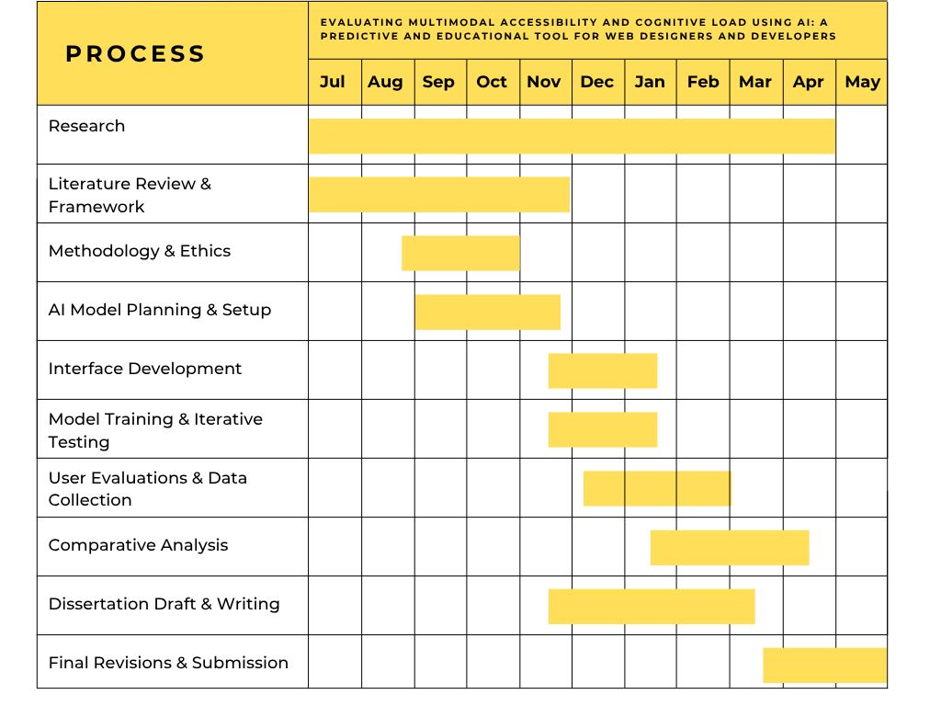

Ethical Considerations.
Refer to guidance points below. You are also additionally required to read MCAST Document 074 ‘Research Ethics Policy and Procedure’ that is available on the College website
Research shall be conducted in such a manner so as to avoid any psychological and physical harm to humans and animals and financial damage to organizations:
- Only the supervisor and examiners will have access to any data gathered.
- Participants will remain free to withdraw from the study at any time without having to provide any reason. In the case of withdrawal, all the records and information collection will be deleted.
- The participant, who is the sole proprietor of the data provided, is granting that such data would be processed for this study purposes only.
- The data collection process will be a transparent process.
- All transcriptions and/or electronic recordings reflecting the data collected, once exhausted, are to be deleted
- Confidentiality, anonymity and data protection procedures are to be ethically abided by.
- The researcher would provide a soft copy of the study to the participant, if required.

Enter details here regarding possibility of issues regarding confidential personal data:
How will you ensure that:
- No personal data or confidential data is divulged.
- Participants’ identities are not divulged (ie kept anonymous)

To ensure confidentiality, no personal or sensitive data will be collected beyond participants’ general roles (e.g., developer, designer, user). All responses will be anonymised using coded identifiers, and no names or contact details will be stored. Data will be securely kept on encrypted systems, accessible only to the researcher and supervisor. Findings will be reported in aggregate form, ensuring that no individual identities or affiliations are revealed during or after the study.

Enter details here regarding possibility of physical harm:
- How will you ensure that no person or animal gets hurt during the implementation of the research?
- What Personal Protective Equipment (PPE) will you be needing/using?

This study does not involve any physical activities that could pose risk to humans or animals. Data collection will occur remotely or in safe, controlled settings with no hazardous equipment. Therefore, the use of Personal Protective Equipment (PPE) is not necessary. If any in-person sessions take place, standard health and safety guidelines will be followed to ensure the well-being of all participants and researchers involved.

Enter details here regarding possibility of moral harm:
- What steps will you take to avoid unduly offending or disturbing the well-being of the participants?
- How will you avoid any possible psychological, spiritual or cultural offence to participants?
- How will you ensure that the interests and rights of minors / vulnerable / disabled persons / specific social groups are safeguarded where necessary?

Participants will be fully informed about the nature and purpose of the research, and they may withdraw at any time without consequence. All materials will be respectful, accessible, and inclusive, with particular attention to the needs of disabled users. Neutral language will be used throughout. Following Creswell’s ethical principles, participant well-being and dignity will be prioritised, and settings will be selected to avoid psychological, cultural, or spiritual offence.

Enter details here regarding possibility of business harm:
How will you ensure that:
- Participants do not suffer any competitive disadvantage as an outcome of the research?
- Confidential business ideas and data are protected and not divulged?

No confidential business information will be requested or disclosed during the study. Participating individuals or organisations will remain anonymous, and any insights shared will be generalised in the final report. Proprietary code, methods, or trade practices will not be collected or published. By ensuring anonymity and avoiding sensitive content, the study guarantees that participants will not experience competitive disadvantage or reputational harm as a result of their involvement.

Please see Annex 1 for a sample Participant Information Letter and Annex 2 for a sample Participant Consent Form. Student is to submit a copy of the proposed Participant Information Letter and Participant Consent Form where applicable. Both documents should be attached to the end of the SOI that is being submitted by the student.

List of Key References:

[1] C. Huang, A. Ma, S. Vyasamudri, E. Puype, S. Kamal, J. B. Garcia, S. Cheema, and M. Lutz, "ACCESS: Prompt Engineering for Automated Web Accessibility Violation Corrections," in Proc. Int. Conf. Learn. Representations (ICLR), 2024. [Online]. Available: https://arxiv.org/abs/2401.16450
[2] N. A. S. Al-Maliki, H. Al-Khalifa, and A. Alqahtani, "Accessibility Engineering in Web Evaluation Process: A Systematic Literature Review," IEEE Access, vol. 10, pp. 132527-132546, 2022, doi: 10.1109/ACCESS.2022.3222064.
[4] I. H. Madu and C. Nzenwa, “AI in Web Development: Enhancing Accessibility,” SSRN Electronic Journal, 2025. doi: 10.2139/ssrn.4949516. [Online]. Available: https://papers.ssrn.com/sol3/papers.cfm?abstract_id=4949516
[5] M. Gerlich, "AI Tools in Society: Impacts on Cognitive Offloading and the Future of Critical Thinking," Societies, vol. 15, no. 1, p. 6, Jan. 2025, doi: 10.3390/soc15010006.
[6] W. Syed, "AI-Powered Multi-Modal Form Filling: Advancing Accessibility through Voice and Image Recognition," Int. J. Sci. Res. Comput. Sci. Eng. Inf. Technol., vol. 11, no. 1, pp. 01-11, Jan.-Feb. 2025, doi: 10.32628/CSEIT25111203.
[7] R. A. Salman, "Artificial Intelligence in Web Accessibility: Potentials and Possible Challenges," International Journal of Advanced Computer Science and Applications (IJACSA), vol. 12, no. 5, pp. 173-179, 2021, doi: 10.14569/IJACSA.2021.0120521.
[8] R. Kuber, W. Yu, P. Strain, E. Murphy, and G. McAllister, "Assistive Multimodal Interfaces for Improving Web Accessibility," in Proc. CHI Workshop on Haptic and Audio Interaction Design, Queen’s Univ. Belfast, 2001.
[11] L. Ding, J. Terwilliger, A. Parab, M. Wang, L. Fridman, B. Mehler, and B. Reimer, "CLERA: A Unified Model for Joint Cognitive Load and Eye Region Analysis in the Wild," ACM Trans. Comput.-Hum. Interact., Jun. 2023, doi: 10.1145/3603622.
[12] P. Mowar, Y.-H. Peng, J. Wu, A. Steinfeld, and J. P. Bigham, "CodeA11y: Making AI Coding Assistants Useful for Accessible Web Development," in Proc. CHI Conf. Human Factors in Comput. Syst. (CHI ’25), Yokohama, Japan, Apr. 26-May 1, 2025, pp. 1-15. doi: 10.1145/3706598.3713335.
[13] T. Schulz and M. T. Knierim, "Cognitive Load Dynamics in Generative AI-Assistance: A NeuroIS Study," in Proc. Int. Conf. Inf. Syst. (ICIS 2024), Bangkok, Thailand, Dec. 2024. [Online]. Available: https://aisel.aisnet.org/icis2024/aiinbus/aiinbus/12
[14] P. Macedo, R. N. Madeira, P. Miranda, and P. A. Santos, "Crafting Personalised Web Interfaces: Enhancing Accessibility for Persons with Disabilities," Int. J. Online Biomed. Eng. (iJOE), vol. 20, no. 13, pp. 84-102, 2024, doi: 10.3991/ijoe.v20i13.50025.
[17] P. Tzonkova, "Eye tracking-based evaluation of accessible and usable interactive systems: tool set of guidelines and methodological issues," Journal of Eye Movement Research, vol. 15, no. 3, pp. 1-23, Jun. 2022, doi: 10.16910/jemr.15.3.6.
[18] Y. Yu, B. Ryskeldiev, A. Tsutsui, M. Gillingham, and Y. Wang, "From Cluttered to Clear: Improving the Web Accessibility Design for Screen Reader Users in E-commerce With Generative AI," Proc. ACM Human-Computer Interaction, vol. 1, no. 1, pp. 1-34, Feb. 2025, doi: 10.1145/nnnnnnn.nnnnnnn.
[19] P. Acosta-Vargas, B. Salvador-Acosta, S. Novillo-Villegas, D. Sarantis, and L. Salvador-Ullauri, "Generative Artificial Intelligence and Web Accessibility: Towards an Inclusive and Sustainable Future," Emerging Science Journal, vol. 8, no. 4, pp. 1602-1619, Aug. 2024, doi: 10.28991/ESJ-2024-08-04-021.
[22] J. A. Pita, M. A. Awad, and C. G. Reddick, "On making web accessibility more accessible: Strategy and tools for social good," Univ. Access Inf. Soc., 2022, doi: 10.1007/s10209-022-00892-9
[23] G. Yoo, H. Kim, and S. Hong, "Prediction of Cognitive Load from Electroencephalography Signals Using Long Short-Term Memory Network," Bioengineering, vol. 10, no. 3, p. 361, Mar. 2023, doi: 10.3390/bioengineering10030361.

This section is to be filled in by the representative of the Institute Research Sub-Committee (IRC) prior to forwarding of this Form to the ‘MCAST Research Ethics Committee’ for final ethics approval:
Nature of Ethical Consideration | Outcome (Tick) | Comments/Advice
All ethical issues have been adequately tackled.
Possibility of issues regarding misuse of data or some form of harm.

Details of Representative to the Institute Research Sub-Committee.
Name | Signature
Designation | Date

Annex 1: Participant Information Letter

Sample: 
Title of Research: ___________________________________________________________________
You are being invited to take part in a research study. Before you decide to participate, it is important for you to understand why the research is being done and what it will involve. Please take time to read the following information carefully and discuss it with others if you wish. Ask us if there is anything that is not clear or if you would like more information.
What is the purpose of the study?
This research is being undertaken on…

Why have I been chosen?
You have been chosen because…

Do I have to take part?
It is up to you to decide whether or not your take part. If you decide to take part you will be given this information sheet to keep and be asked to sign a corresponding consent form.

What will happen to me if I take part?
You will then be given a questionnaire on.../your data will be used…/your image will be used…

What are the possible disadvantages and risks of taking part?
There are no disadvantages or risks foreseen in taking part in the study.

What are the possible benefits of taking part?
By taking part you will be contributing to the development of a set of recommendations for…

What if something goes wrong?
If you wish to complain or have any concerns about any aspect of the way in which you have been approached or treated during the course of this study, please contact…(researcher is to give his/her MCAST email as a contact)

Will my details be kept confidential?
All information which is collected about you during the course of the research will be kept strictly confidential so that only the researcher carrying out the research will have access to such information and will not be shared with any other individuals. Participants should note that data/images collected from this project may be retained and published in an anonymized form. By agreeing to participate in this project, you are consenting to the retention and publication of data.

What will happen to the results of the research study?
The results will be written up into a dissertation for my final project of my Bachelor…

Who is organizing the research?
The research is conducted as part of a degree in …

Who may I contact for further information?
If you would like more information about the research before you decide…(researcher is to give his/her MCAST email as a contact)

Thank you for your interest in this research…
Annex 2: Participant (or Guardian) Consent Form

Sample: 

Title of Research: ____________________________
Name of Researcher: ___________________________

Please initial box

- I confirm that I have read and understand the Information Letter
for the above study and have had the opportunity to ask questions.
- I understand that my/my charge’s participation is voluntary and that I/my charge am/are free to withdraw at any time without giving any reason.

3. I agree to allow my daughter/son/charge to take part in the above study.
(Statement 3 is to be included only when guardians/parents are involved in giving consent)

___________________ _________________ _____________
Name of Participant/
Guardian Date Signature

Researcher Date Signature

1 for participant; 1 for researcher

